Setup minikube at your local and explore creating namespaces (Go through official documentation)

Solution:

Launched an Ec2 machine with T2medium spec

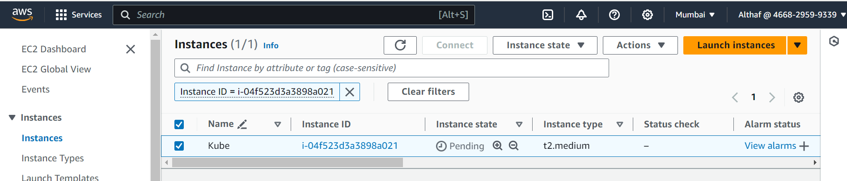

Updating my Ubuntu machine

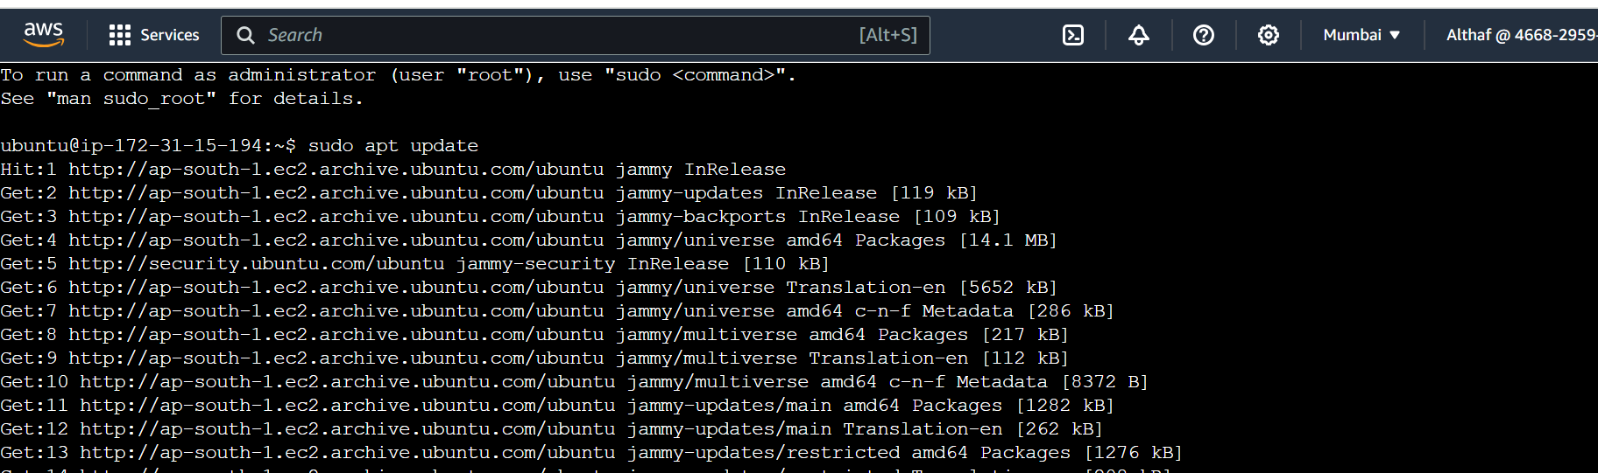

Installing Docker for prerequisite

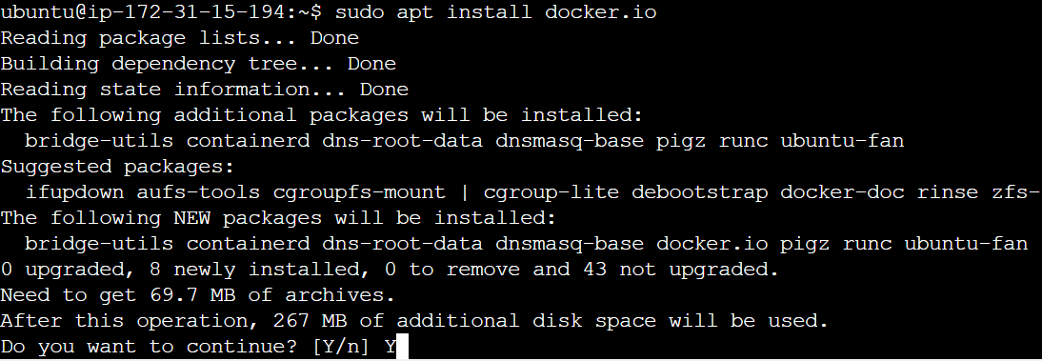

Installed Kubectl on the Ubuntu machine to setup Minikube

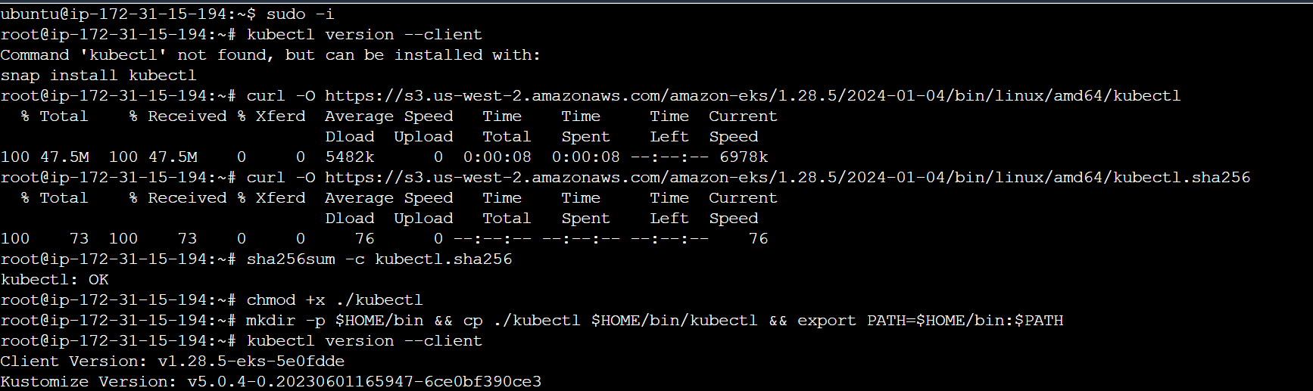



Starting the Minikube

